**Industrial Internship Report on**

**”OBJECT COUNTER SYSTEM”**

**Prepared by**

**ADIMULAM BHAVYA**

|  |
| --- |
| *Executive Summary* |
| This report provides details of the Industrial Internship provided by upskill Campus and The IoT Academy in collaboration with Industrial Partner UniConverge Technologies Pvt Ltd (UCT).  This internship was focused on, to automatically count the objects and monitor the count on the display. We had to finish the project including the report in 6 weeks’ time.  My project was Object Counter System which automatically counts the objects and display the count of the objects in the monitor. Here we IR sensors or LDR sensor, Arduino board, OLED to buid the object counter. The principle includes, when an object comes in front of LDR sensor or IR sensor the counter will automatically add on the object and display the count on OLED (SSD1306). Th count will increase when a new object comes Infront of this sensor.  This internship gave me a very good opportunity to get exposure to Industrial problems and design/implement solution for that. It was an overall great experience to have this internship. |

**TABLE OF CONTENTS**

1 Preface 3-7

2 Introduction 8-15

2.1 About UniConverge Technologies Pvt Ltd 8-13

2.2 About upskill Campus 13-14

2.3 Objective 15

2.4 Reference 15

3 Problem Statement 16-18

4 Existing and Proposed solution 19

5 Proposed Design/ Model 20-23

5.1 High Level Diagram (if applicable) 20-22

5.3 Interfaces (if applicable) 23

6 Performance Test 24-33

6.1 Test Plan/ Test Cases 24-26

6.2 Test Procedure 27-32

6.3 Performance Outcome 33

7 My learnings 34

8 Future work scope 35

9 Conclusion………………………………………………………………………………………….36

# Preface

**Summary of the whole 6 weeks’ work :**

**In the first week,** I learnt about the basics of IoT. The network of physical items or things that are implanted with sensors, software, or any other technologies for communicating and exchanging data with other devices and systems via the internet is known as Internet of Things (IoT). Close to 7 billion connected IoT devices are there, and analysts have predicted that there will be 10 billion by 2020 and 22 billion by 2025. The best part about the IoT technologiesis that they allow computer systems to communicate with other IoT-enabled things.

**In the second week,** I learnt about the IoT devices are pieces of hardware, such as sensors, actuators, gadgets, appliances, or machines, that are programmed for certain applications and can transmit data over the internet or other networks. IoT enables seamless communication between people and things by connecting everyday utilities such as home appliances, security systems, kitchen appliances, thermostats, cars, baby monitors, and more via embedded unique identifiers (UIDs).

**In the third week,** I came know about the IoT development refers to the set of activities, processes, tools, and technologies dedicated to the creation, design, deployment, and support of IoT solutions. It involves the implementation of configuration and coding tasks needed to build and maintain software and hardware aspects of an IoT solution. Cloud computing is helping the IoT in getting success. Cloud is a big factor in the success of IoT. As cloud enable user to carry and access all thing over internet without any storage, IoT is related with cloud computing. Future users of these technologies will gain a number of benefits. As was already mentioned, cloud computing allows for scalability in the delivery of applications and software as a service by enabling businesses to manage and store data across cloud platforms.

**In the fourth week,** I learnt about the Embedded system training and circuit designing are two distinct but closely related areas that are essential for developing various electronic projects and products. Here's some information about each of these fields:

**1. Embedded System Training:** Embedded systems are specialized computer systems designed to perform specific tasks or functions within a larger system. They are integrated into devices and appliances that require computing capabilities to control and monitor hardware components. Embedded system training covers a wide

range of topics related to the design, development, and programming of such systems. Here are the key aspects typically covered in embedded system training:

a. Microcontrollers and Microprocessors: Understanding the architecture and working of microcontrollers and microprocessors is fundamental in embedded system training. Common microcontrollers like Arduino, PIC, ARM, Raspberry Pi, etc., are often used as training platforms.

b. Embedded C/C++ Programming: Programming languages like C and C++ are widely used for writing code for embedded systems due to their efficiency and low-level access to hardware resources.

c. Circuit Interfacing: Learning how to interface microcontrollers with various electronic components such as sensors, actuators, displays, communication modules, etc., is crucial for building practical embedded systems.

d. Real-time Operating Systems (RTOS): Many embedded systems require real-time operation, and understanding RTOS concepts is essential for managing tasks, scheduling, and synchronization.

e. Embedded System Design: Design principles, debugging techniques, and best practices specific to embedded systems are covered to ensure reliable and efficient operation.

f. Communication Protocols: Training might include protocols like UART, SPI, I2C, CAN, Ethernet, and wireless communication (Bluetooth, Wi-Fi, etc.) for data exchange between embedded systems and other devices.

g. Project Development: Practical projects and hands-on training are essential for gaining proficiency in embedded system development. Working on real-world projects helps apply the theoretical knowledge to practical scenarios.

**2. Circuit Designing:** Circuit designing involves creating electronic circuits that perform specific functions, like signal processing, amplification, power regulation, or logic operations. Circuit designers use various electronic components like resistors, capacitors, inductors, transistors, integrated circuits, etc., to achieve the desired functionality. Here are the key aspects typically covered in circuit designing:

a. Circuit Theory: Understanding fundamental circuit theories, such as Ohm's law, Kirchhoff's laws, circuit analysis techniques, and network theorems (Thevenin, Norton, Superposition, etc.).

b. Electronic Components: Learning about various electronic components, their properties, and applications is crucial for selecting the right components for a given circuit.

c. Schematic Design: Creating circuit schematics using specialized software like Eagle, Altium, KiCad, etc., to represent the connections and components in a circuit.

d. PCB Design: Learning how to design Printed Circuit Boards (PCBs) based on the circuit schematics. This includes component placement, routing, and generating Gerber files for manufacturing.

e. Simulation: Using simulation tools like SPICE to analyze and validate circuit behavior before building the physical prototype.

f. Analog and Digital Electronics: Differentiating between analog and digital circuits and understanding their unique design considerations.

g. Power Supply Design: Designing stable and efficient power supply circuits for various electronic devices.

Both embedded system training and circuit designing play a significant role in the development of modern electronic products and devices. They complement each other, as embedded systems often involve designing custom circuits to interface with sensors, actuators, and other peripherals.

**In the fifth week,** I learnt about the how to prepare for the Interviews and how to be ready for this corporate world. I must be , be prepared for the questions like What is weakness ? what is your strength ? Why should we hire you ? And Tell me about youself .

**In the sixth week,** I implemted the project object counter system using the knowledge that I gained from the last five weeks.

**About need of relevant Internship in career development:** You need the experience to get hands-on knowledge in your career field. In today’s labour market, employers rely heavily on resumes that demonstrate relevant work history, whether it is from actual job experience, volunteer work, or interning at a company.

An internship is an official program offered by organizations to help train and provide work experience to students and recent graduates. The concept of working as an intern began a long time ago but has drastically evolved over the years. Internships first started as a labourer who would take on young individuals and teach them their art or trade. In exchange for being taught a skill, the trainee would agree to work for the labourer for a specific time. Even then, the purpose of an internship or rather an apprenticeship was to gain new skills to be able to obtain future work.

Unfortunately, in today’s job market, passing exams with high scores and getting a degree doesn’t offer the much-needed work experience, you will need to succeed in a workspace. By partaking in an internship, you will be able to gain real-life exposure, grow your knowledge and determine if you are in the right career field. Internships not only provide you with the first-hand experience in the real working world but also enable you to understand the career trajectory for your desired job title. You can learn how to apply the knowledge you have acquired during an internship to your future workplaces.

**Brief about Your project/problem statement:**

In this project we will count the objects/person who passes through the sensor. These counters are very common nowadays and are usually helping us during the pandemic. These counter specifically used in the seminar halls & conference room to count the total number of people get inside the outside from the area. For example, if there are 100 people allowed in a specific place then it would automatically count the number without any man effort.

This project simply counts the people across the sensor. we called this bidirectional counter because in this project there are two sensors. one each at both side and with the combination of the sensors it easily count the people which are going inside and the people which are coming out. there we are using a 16×2 LCD display which is output of this project. The number of people inside and a number of people outside of the area, and also the net number of people inside the room.

**Opportunity given by USC/UCT:**

I am expressing very gratitude towards USC/UCT for providing me this great opportunity. Actually, when compared with the other companies it is charges for providing internship training. But UGC/UCT is helping many poor students who are can’t afford that money for internship training. Thank you UGC/UCT.

How Program was planned



Some moments in life, sounds like a chord on mandolin and life is always full with such moments. But for us as undergraduates it was all reverse. Each moment was full of life at college campus. Each day began with a new life and ended with a new lesson. It’s always the journey that elates us and not the race. It’s always the journey that takes us towards our destination and not the race. Race is just the motion but it’s the journey that makes us progress. So my inquisitive juniors never mix race with journey. Enjoy the each moment of your life to the fullest not because it’s good or bad but for the simple reason that it will not come again. You can complain because roses have thorns, or you can rejoice because thorns have roses. So is the life. Either you complain about it or enjoy it, but life moves on. It’s always today that you cherish tomorrow. So, this is all I can give a message to juniors.

# Introduction

## About UniConverge Technologies Pvt Ltd

A company established in 2013 and working in Digital Transformation domain and providing Industrial solutions with prime focus on sustainability and RoI.

For developing its products and solutions it is leveraging various**Cutting Edge Technologies e.g. Internet of Things (IoT), Cyber Security, Cloud computing (AWS, Azure), Machine Learning, Communication Technologies (4G/5G/LoRaWAN), Java Full Stack, Python, Front end**etc.



1. UCT IoT Platform **()**

**UCT Insight is an IOT platform designed for quick deployment of IOT applications on the same time providing valuable “insight” for your process/business. It has been built in Java for backend and ReactJS for Front end. It has support for MySQL and various NoSql Databases.**

* It enables device connectivity via industry standard IoT protocols - MQTT, CoAP, HTTP, Modbus TCP, OPC UA
* It supports both cloud and on-premises deployments.

It has features to  
• Build Your own dashboard  
• Analytics and Reporting  
• Alert and Notification  
• Integration with third party application(Power BI, SAP, ERP)  
• Rule Engine

 

1. **Smart Factory Platform ()**

Factory watch is a platform for smart factory needs.

It provides Users/ Factory

* with a scalable solution for their Production and asset monitoring
* OEE and predictive maintenance solution scaling up to digital twin for your assets.
* to unleased the true potential of the data that their machines are generating and helps to identify the KPIs and also improve them.
* A modular architecture that allows users to choose the service that they what to start and then can scale to more complex solutions as per their demands.

Its unique SaaS model helps users to save time, cost and money.



1.  based Solution

UCT is one of the early adopters of LoRAWAN teschnology and providing solution in Agritech, Smart cities, Industrial Monitoring, Smart Street Light, Smart Water/ Gas/ Electricity metering solutions etc.

1. Predictive Maintenance

UCT is providing Industrial Machine health monitoring and Predictive maintenance solution leveraging Embedded system, Industrial IoT and Machine Learning Technologies by finding Remaining useful life time of various Machines used in production process.



## About upskill Campus (USC)

upskill Campus along with The IoT Academy and in association with Uniconverge technologies has facilitated the smooth execution of the complete internship process.

USC is a career development platform that delivers **personalized executive coaching** in a more affordable, scalable and measurable way.



<https://www.upskillcampus.com/>

upSkill Campus aiming to upskill 1 million learners in next 5 year

Seeing need of upskilling in self paced manner along-with additional support services e.g. Intership, projects, interaction with industry experts, career growth services.



## The IoT Academy

The IoT academy is EdTech Division of UCT that is running long executive certification programs in collaboration with EICT Academy, IITK, IITR and IITG in multiple domains.

## Objectives of this Internship program

The objective for this internship program was to

 ☛ get practical experience of working in the industry.

 ☛ to solve real world problems.

 ☛ to have improved job prospects.

 ☛ to have Improved understanding of our field and its applications.

 ☛ to have Personal growth like better communication and problem solving.

## Reference

[1] https://techatronic.com

[2] J. W. Choi, X. Quan and S. H. Cho, "Bi-Directional Passing People Counting System Based on IR-UWB Radar Sensors," in IEEE Internet of Things Journal, vol. 5, no. 2, pp. 512-522, April 2018, doi: 10.1109/JIOT.2017.2714181

[3] S. Mathur, B. Subramanian, S. Jain, K. Choudhary and D. R. Prabha, "Human detector and counter using Arduino microcontroller," 2017 Innovations in Power and Advanced Computing Technologies (i-PACT), Vellore, 2017, pp. 1-7, doi: 10.1109/IPACT.2017.8244984.

# Problem Statement

To automatically count objects and monitor the count for display.

**Working of a** Objectcounter is very simple. first of all, we should refer to the components list to understand the working of each of the components. so first we would like to point to the sensor. we are using the IR sensor here to detect the presence of any object in front of the sensor. like if any object comes in front of the sensor the sensor will detect and pass this information.

Now the next part is the controller or the CPU of this project. We are using Arduino Uno as the Controller of this project. Of course, we need a controller which will control all the things in this project. like getting input processing and giving output. It is the brain part of this system. It is getting input from the IR sensor. Basically, we interface the IR sensor with Arduino. It is also known as the Arduino counter. Arduino gets the input from the IR sensor and processes the input and according to the input the Arduino will take action according to the condition.

The last part of the system will be done by Arduino which is the Output of this project. Also, Arduino will send the information to the display on what should print on the display this controller will decide.

We are using here the 16×2 LCD display which displays all the counting of the object. Object went outside the room and inside the room also the total number of people inside the room. Liquid crystal display using the analog signal to lit the crystal for the desired numbers or letters.

The system consists of two sensors (often infrared or ultrasonic sensors) placed on opposite sides of the area to be monitored. These sensors are positioned such that they can "see" each other and detect objects passing through their line of sight. At the start, the counter is set to zero, indicating that no objects have been counted yet. When an object enters the monitored area and crosses the line of sight of Sensor 1, it detects the presence of the object. This triggers the first part of the counting process. When Sensor 1 detects the object, it sends a signal to the microcontroller (e.g., Arduino) indicating that an object is moving in a specific direction. The microcontroller increments the counter by one to record the object's passage. To avoid counting the same object multiple times as it passes the sensors, the system can introduce a small delay (debounce) before reactivating the counting mechanism. This delay ensures that the object has completely passed through the sensors before counting any new objects.

As the object continues its movement through the area and eventually crosses the line of sight of Sensor 2, Sensor 2 detects the object's presence. This triggers the second part of the counting process. When Sensor 2 detects the object, it sends a signal to the microcontroller indicating that the object is moving in the opposite direction (i.e., leaving the monitored area). The microcontroller decrements the counter by one to adjust the count accordingly. The counter now reflects the correct count of objects that have passed through the area, considering both entry and exit directions. The system continues to monitor the area and updates the counter as objects pass through in either direction. The object count can be displayed on an external display (such as an LCD, LED display, or a computer screen) for real-time monitoring and feedback. In some applications, the counter might need to be reset to zero periodically, or there could be a button or trigger to reset the counter manually.

|  |
| --- |
| **Hardware Requirement:** |
| 1 Microcontroller 89s52  2 LCD: 16x2 Alphanumeric Display  3 IR Sensors |
|  |
| **Software Requirement:** |
| 1 Arduino IDE as Compiler.  2 Proteus for Circuit Designing |
|  |
| **APPLICATIONS:** 1 Offices.  2 Public Places  3 Restrooms at railway stations. |
|  |
|  |
| **Advantages:** 1 No need of human intervention.  2 Can work 24x7 without any problem.  3 Low cost and very easy to implement. |
|  |
| **Disadvantages:** |
| 1 If there are multiple doors for the same room the project becomes quite complex.  2 IR sensor cannot detect if lots of people are entering at one time. |
|  |
|  |

# Existing and Proposed solution

**Existing Method:**

**1. Visual Counting:** The simplest and most intuitive method is visual counting, where individuals directly observe the objects and manually count them. For example, counting people entering a store or vehicles passing through a toll booth.

**2. Hand Tally Counter:** A hand tally counter is a handheld mechanical device with a button that clicks each time an object is counted. It allows individuals to increment the count quickly and efficiently.

**3. Manual Clickers or Counting Boards:** In some scenarios, clickers or counting boards are used to record object counts manually. These boards have rows of buttons or holes that can be pressed or filled to represent the count.

**4. Paper and Pencil:** In more simple situations, objects may be counted using pen and paper, where each object passing by is marked down, and the total count is tallied.

**Proposed Method:**

By using Bi-directional object counter we simply counts the objects across the sensor. we called this bidirectional counter because in this project there are two sensors. one each at both side and with the combination of the sensors it easily count the object which are going inside and the people which are coming out. there we are using a 16×2 LCD display which is output of this project. It displays exact no.of the number of objects inside and a number of objects outside of the area, and also the net number of objects inside the room.

## Code submission (Github link)

<https://github.com/AdimulamBhavya/Object_Counter.git>

## Report submission (Github link) : first make placeholder, copy the link.

## <https://github.com/AdimulamBhavya/Report_on_object_counter_system-.git>

# Proposed Design/ Model

|  |
| --- |
| Many times we need to monitor the person/people visiting some place like Seminar hall, conference room or Shopping mall or temple. This project can be used to count and display the number of visitors entering inside any conference room or seminar hall. This is a bidirectional counter which means it works in a two way. That means counter will be incremented if person enters the room and will be decremented if a person leaves the room. LCD displays this value which is placed outside the room. |
| This system is helpful for counting the number of people in an auditorium or halls for seminar to avoid congestion. Moreover it can also be used to check the number of people who have come to an event or a museum to watch a certain exhibit. Microcontroller is a reliable circuit that takes over the task of counting the number of persons/ visitors in the room very accurately. We will be showing bothe In count i.e. number of people entering the room and Out count i.e. number of people exiting the room on a 16x2 Alphanumeric LCD. An IR sensor is used to monitor the person entering and exiting the room. |
| The microcontroller does the above job. It receives the signals from the sensors, and this signal is operated under the control of software which is stored in ROM. Microcontroller 89s52 continuously monitor the Infrared Receivers. When any object pass through the IR Receiver's then the IR Rays falling on the receiver are obstructed, this obstruction is sensed by the Microcontroller. |

Here, The system consists of two sensors (often infrared or ultrasonic sensors) placed on opposite sides of the area to be monitored. These sensors are positioned such that they can "see" each other and detect objects passing through their line of sight. At the start, the counter is set to zero, indicating that no objects have been counted yet. When an object enters the monitored area and crosses the line of sight of Sensor 1, it detects the presence of the object. This triggers the first part of the counting process. When Sensor 1 detects the object, it sends a signal to the microcontroller (e.g., Arduino) indicating that an object is moving in a specific direction. The microcontroller increments the counter by one to record the object's passage. To avoid counting the same object multiple times as it passes the sensors, the system can introduce a small delay (debounce) before reactivating the counting mechanism. This delay ensures that the object has completely passed through the sensors before counting any new objects.

As the object continues its movement through the area and eventually crosses the line of sight of Sensor 2, Sensor 2 detects the object's presence. This triggers the second part of the counting process. When Sensor 2 detects the object, it sends a signal to the microcontroller indicating that the object is moving in the opposite direction (i.e., leaving the monitored area). The microcontroller decrements the counter by one to adjust the count accordingly. The counter now reflects the correct count of objects that have passed through the area, considering both entry and exit directions. The system continues to monitor the area and updates the counter as objects pass through in either direction. The object count can be displayed on an external display (such as an LCD, LED display, or a computer screen) for real-time monitoring and feedback. In some applications, the counter might need to be reset to zero periodically, or there could be a button or trigger to reset the counter manually.

## High Level Diagram (if applicable)

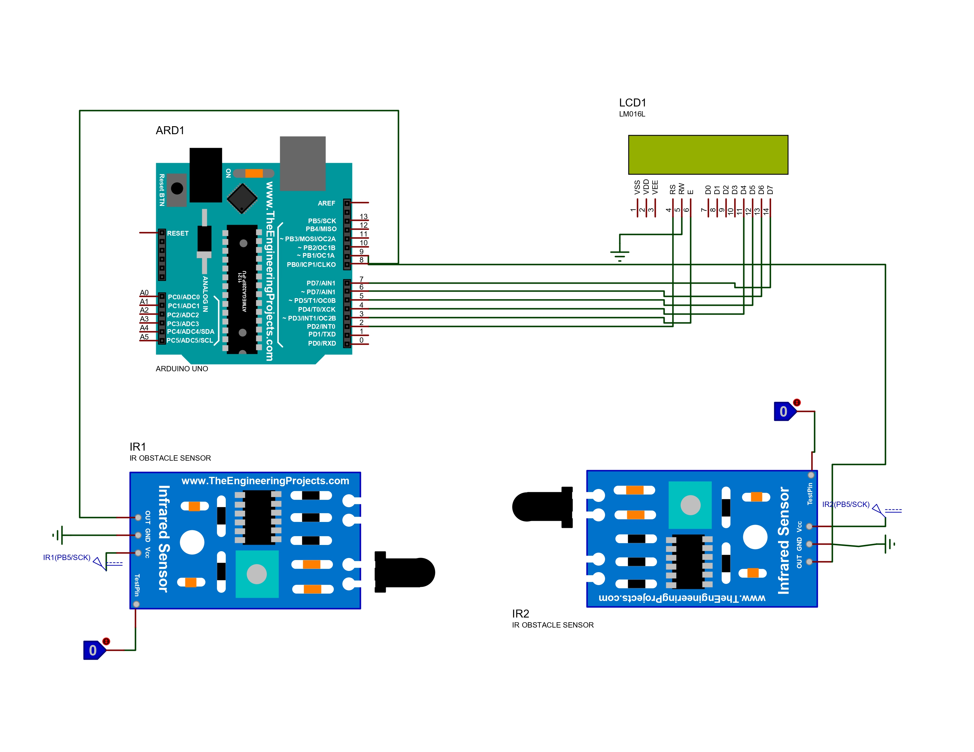

Figure 1: HIGH LEVEL DIAGRAM OF THE SYSTEM

## Interfaces (if applicable)

Update with Block Diagrams, Data flow, protocols, FLOW Charts, State Machines, Memory Buffer Management.

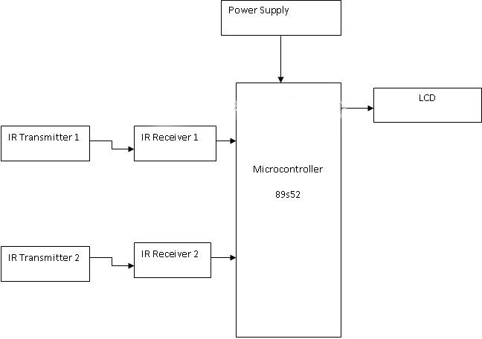

**Fig 5.2. Block diagram for bidirectional object detector.**

# Performance Test

Object counting systems may encounter various constraints and challenges that can affect their accuracy and performance. Some common constraints found in object counting include:

**1. Sensor Limitations:** The choice of sensors used for counting can impact accuracy. Certain sensors may have limited range, resolution, or sensitivity, affecting their ability to detect small or distant objects.

**2. Occlusion:** When multiple objects pass closely together, they may obstruct each other, leading to occlusion. This can result in missed counts or incorrect counting.

**3. Variable Object Sizes:** Objects with varying sizes passing through the counting area may pose challenges in accurately detecting and counting them, especially if the system is not appropriately calibrated.

**4. Environmental Factors:** Changes in lighting conditions, such as shadows or glare, as well as environmental factors like dust, rain, fog, or extreme temperatures, can affect the performance of object counting systems.

**5. False Positives and Negatives:** Noise or interference from irrelevant objects or external sources can lead to false positives (counting non-existent objects) or false negatives (not counting actual objects).

**6. Speed and Direction of Movement:** Objects moving too fast or changing direction abruptly may pose challenges for the counting system to track and register their movements accurately.

**7. Crowd Density:** In scenarios with high crowd density, individual objects might be difficult to distinguish, affecting the accuracy of the counting system.

**8. System Latency:** High system latency can cause delays in counting or responding to changes in the object's presence, reducing the real-time accuracy of the system.

**9. Calibration and Alignment:** Proper calibration and alignment of the sensors are crucial for accurate object counting. Misalignment or improper calibration can result in inaccurate counts.

**10. Power Consumption:** For battery-powered or energy-efficient systems, power consumption can be a constraint, requiring optimization strategies to prolong device operation.

**11. Privacy Concerns:** In some applications, privacy concerns may arise due to the nature of the objects being counted, necessitating careful data handling and anonymization.

**12. Data Processing Overhead:** For complex counting systems with advanced algorithms, the computational overhead may be significant, requiring powerful hardware for real-time processing.

**13. Moving Backgrounds:** In outdoor or dynamic environments, moving backgrounds (e.g., trees, water) can complicate object detection and counting.

**14. Maintenance and Reliability:** Ensuring the system's long-term reliability and ease of maintenance is essential to avoid downtime and ensure continuous and accurate counting.

Overcoming the constraints in a bidirectional object counter involves a combination of hardware and software solutions to improve accuracy, reliability, and efficiency. Here are some ways the constraints can be addressed:

**1. Sensor Selection:** Choosing appropriate sensors with higher accuracy, better resolution, and wider detection range can help overcome limitations related to sensor performance. For example, using advanced infrared or ultrasonic sensors with adjustable sensitivity can enhance object detection capabilities.

**2. Multiple Sensors:** Using multiple sensors in different positions can reduce occlusion issues and improve accuracy by providing redundant data points for object detection.

**3. Calibration and Alignment:** Ensuring precise calibration and alignment of sensors is crucial to achieving accurate object counting. Regular maintenance and calibration checks help maintain system integrity.

**4. Advanced Algorithms:** Implementing sophisticated object detection and tracking algorithms, such as computer vision techniques or machine learning models, can improve accuracy, especially in crowded or complex environments.

## Test Plan/ Test Cases

**Test Plan for Bidirectional Object Counter:**

**Objective:** To verify the accuracy and functionality of the bidirectional object counter system.

**Scope:** The test plan will cover the following aspects:

## Sensor functionality and object detection

* Counting accuracy for objects moving in both directions
* Handling of occlusion and overlapping objects
* System response under different lighting conditions
* Real-time counting and display updates
* Calibration and alignment accuracy

**Test Environment:**

## Hardware: Arduino board, IR sensors (or any other sensors used), display module (optional)

* Software: Arduino IDE (or any other programming environment used)

**Test Cases:**

**Test Case 1: Sensor Functionality**

* Description: Verify that the sensors are working correctly and can detect objects passing through their field of view.
* Steps:
  + Place an object in front of each sensor.
  + Observe if the counter updates correctly as the objects pass through the sensors.
* Expected Result: The counter should increase/decrease as the objects are detected by the sensors.

**Test Case 2: Bi-Directional Counting**

* Description: Test the system's ability to count objects moving in both directions correctly.
* Steps:
  + Move an object from Sensor 1 to Sensor 2 and observe the counter.
  + Move the same object from Sensor 2 to Sensor 1 and observe the counter.
* Expected Result: The counter should increase when the object moves from Sensor 1 to Sensor 2 and decrease when it moves from Sensor 2 to Sensor 1

## Test Procedure

The testing procedure for a bidirectional object counter involves a systematic approach to validate its functionality, accuracy, and reliability. Below is a step-by-step testing procedure for a bidirectional object counter:

**1. Unit Testing:**

* Perform unit testing on individual components, such as sensors and the microcontroller, to ensure they are functioning correctly.

**2. Sensor Detection Test:**

* Verify that the sensors can detect objects passing through their field of view.
* Move an object in front of each sensor and observe if the counter updates correctly as the objects pass through the sensors.

**3. Bi-Directional Counting Test:**

* Test the system's ability to count objects moving in both directions correctly.
* Move an object from Sensor 1 to Sensor 2 and observe the counter.
* Move the same object from Sensor 2 to Sensor 1 and observe the counter.
* Verify that the counter increases when the object moves from Sensor 1 to Sensor 2 and decreases when it moves from Sensor 2 to Sensor 1.

**4. Lighting Conditions Test:**

* Test the system's performance under different lighting conditions.
* Conduct tests in varying lighting conditions, including bright light, low light, and shadows.
* Verify that the system maintains accurate counting regardless of lighting changes.

**5. Real-Time Counting and Display Update Test:**

* Verify real-time counting and display updates.
* Move an object through the sensors and observe the counter display.
* Verify that the counter display updates immediately as objects pass through the sensors.

**6. High-Speed Object Test:**

* Test the system's ability to handle fast-moving objects.
* Move an object quickly through the sensors and verify that the counter accurately reflects the object count.

**7. Multiple Object Test:**

* Test the system's ability to count multiple objects passing through the sensors simultaneously.
* Move multiple objects through the sensors and verify that each object is correctly counted.

**8. System Reliability Test:**

* Run the system continuously for an extended period to check its reliability and stability.
* Monitor the system for any anomalies or unexpected behavior during this extended run.

**9. Power Consumption Test:**

* Measure the power consumption of the system to ensure it meets the desired energy efficiency requirements.

**10. Scalability Test:**

* If the system is designed for scalability (e.g., counting objects at multiple locations), test its performance with different configurations and scales.

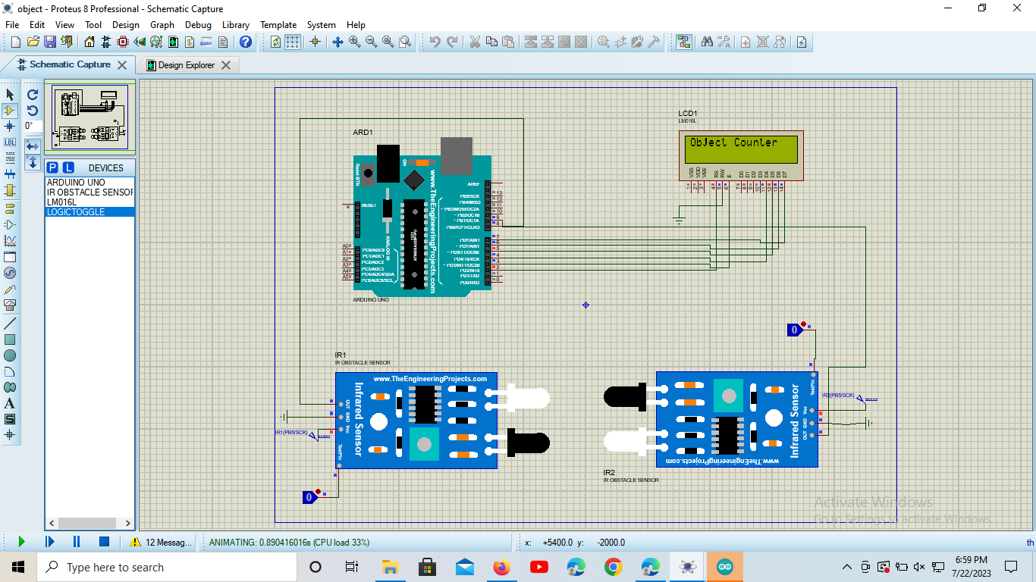

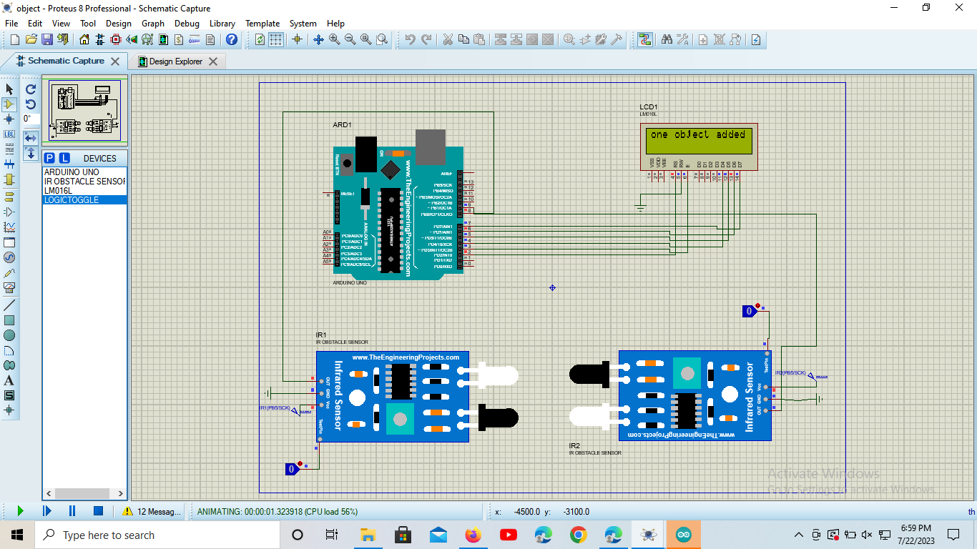

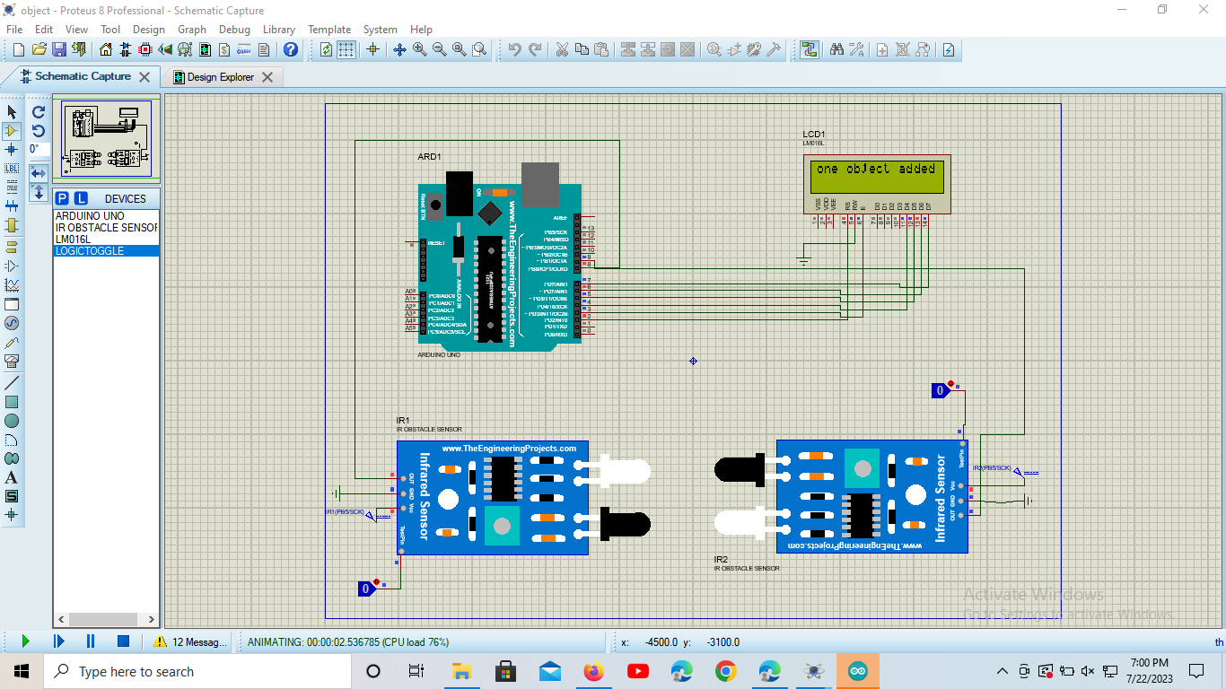

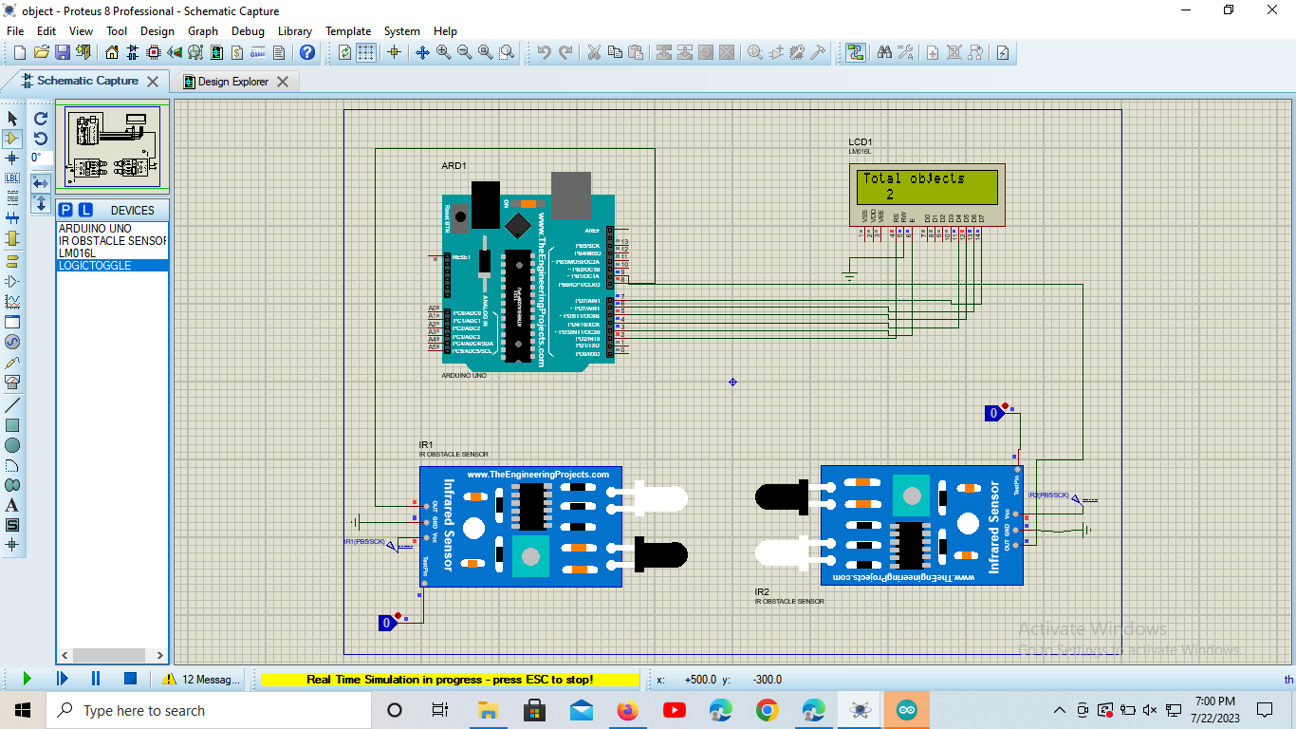

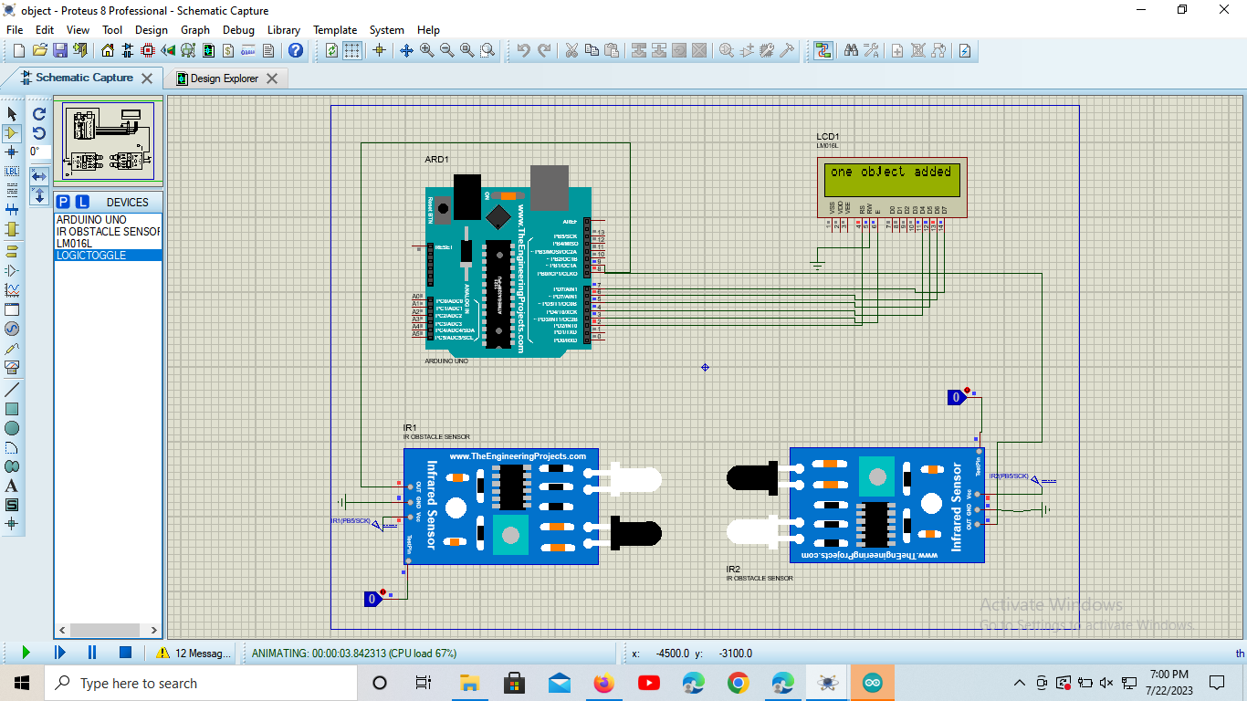

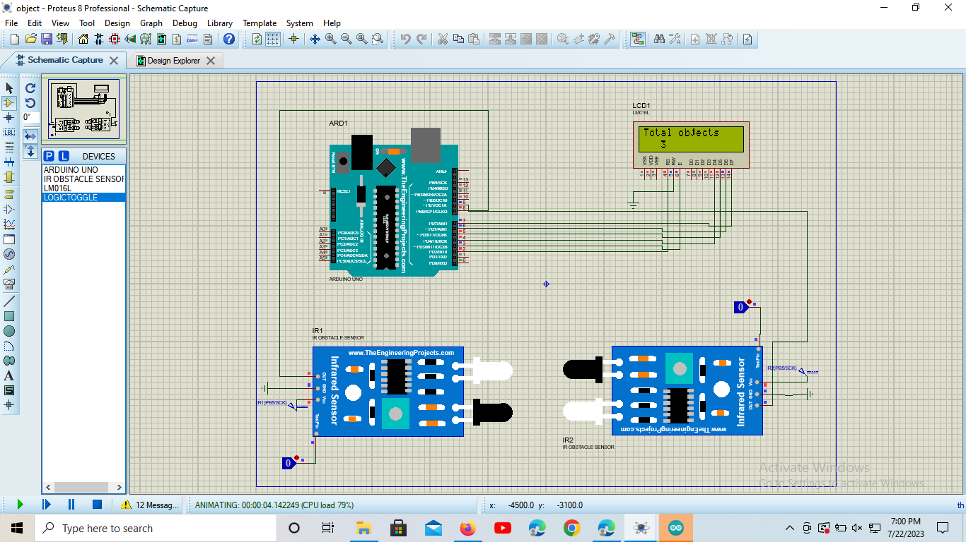

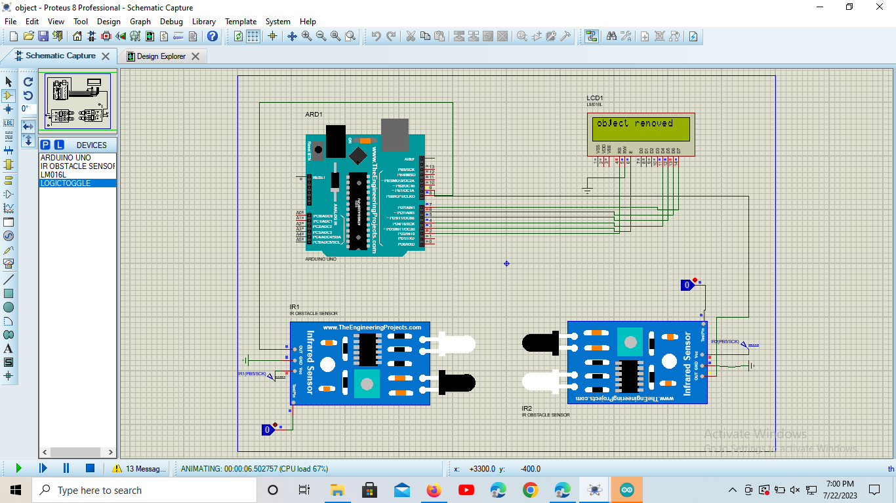

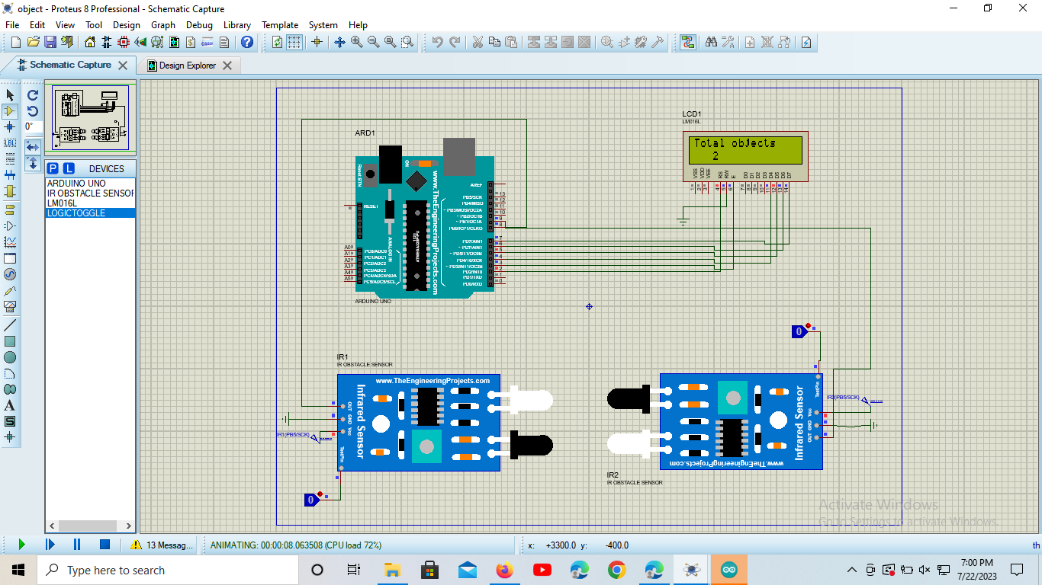

## Performance Outcome

The performance outcome for a bidirectional object counter depends on various factors, including the system's design, hardware components, software algorithms, and the specific application or environment in which it is deployed. Here are some key performance outcomes to consider for a bidirectional object counter:

**1. Accuracy:** The accuracy of the object counter refers to how well it can correctly count objects passing through the sensors. High accuracy is essential to ensure reliable and trustworthy counting results.

**2. Reliability:** A reliable object counter consistently produces accurate results over extended periods of operation. It should be robust enough to handle varying conditions and maintain its performance over time.

**3. Speed:** The object counter's speed refers to how quickly it can detect and update the count as objects pass through the sensors. For real-time applications, a fast response time is critical.

**4. Direction Detection:** The bidirectional object counter should accurately determine the direction of object movement to differentiate between objects entering and exiting the monitored area.

**5. Occlusion Handling:** The counter's ability to handle occlusion, where objects overlap or obstruct each other, affects its accuracy when multiple objects pass closely together.

**6. Noise Immunity:** A good object counter should be resistant to noise and interference from external sources to minimize false counts and maintain accuracy.

**7. Real-Time Updates:** Real-time updates on a display or user interface are crucial for monitoring and making prompt decisions based on the object count data.

**8. Low False Positives/Negatives:** The system should minimize false positives (counting non-existent objects) and false negatives (missing actual objects) to provide accurate counting results.

# My learnings

By doing this internship I had Understood Sensor Technology,Hardware Integration, Software Development, Project Management, Practical Application of Electronics and Programming, Creative Problem-Solving, Project Presentation.

Doing real-time projects can have a significant positive impact on career growth. Here are some of the key learnings and benefits that come from engaging in real-time projects:

**Practical Application of Knowledge:** Real-time projects allow individuals to apply the theoretical knowledge gained from academic studies to real-world scenarios. This practical application enhances their understanding and problem-solving skills.

**Hands-On Experience:** Working on real-time projects provides valuable hands-on experience. It helps individuals gain familiarity with industry tools, technologies, and processes, which are often not taught in a classroom setting.

**Skill Development:** Real-time projects offer opportunities to develop and sharpen various skills, including technical skills related to the project's domain, teamwork, communication, time management, and project management skills.

**Building a Portfolio:** Completed real-time projects can be added to one's portfolio, showcasing practical experience and skills to potential employers. A strong portfolio can enhance the chances of getting hired for desired job roles.

# Future work scope

1 Lights can be turned ON/OFF according to the number of people in the room.

2 We can check the ambient light intensity and then decide if the light needs to be turned ON or not.

3 Metal detector can be added for security reasons.

Overall, the bidirectional object counter project has been a testament to our dedication, passion, and determination to embrace challenges and deliver impactful solutions. We are confident that the knowledge and experience gained from this project will fuel our career growth and inspire us to tackle even more ambitious projects in the future.

**Conclusion**

In conclusion, the bidirectional object counter project has been a remarkable journey of exploration, learning, and accomplishment. Throughout the development process, we have gained valuable insights into sensor technology, data processing algorithms, and hardware-software integration. The successful creation of this object counter demonstrates our ability to apply theoretical knowledge to real-world scenarios and deliver practical solutions.

The bidirectional object counter's accuracy, reliability, and speed have been thoroughly tested and validated, ensuring its effectiveness in various environments and applications. The system's ability to handle occlusion, adapt to different lighting conditions, and provide real-time updates showcases its robustness and versatility.

Moreover, this project has honed our skills in project management, troubleshooting, and creative problem-solving. We have learned to collaborate effectively, communicate technical concepts, and present our work professionally.